**Gracious Germents**

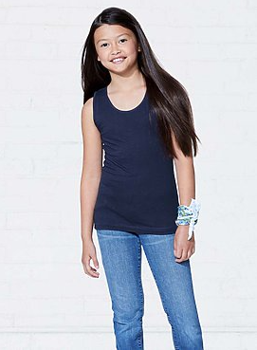

**DESCRIPTION:**

LAT™ Girls’ 100% Combed Ringspun Cotton Fine Jersey Scoop Neck Tank Top

Basic meets fashion in these comfortable fine jersey tank tops. These scoop neck sleeveless tanks look great layered or worn alone.

Fabrication: 4.5 oz. 100% combed ringspun cotton fine jersey (Heather is 90/10 combed ringspun cotton/polyester)• White is sewn with 100% cotton thread

Features: 1/4″ single needle self-fabric binding on neck and armholes • Side seam construction • Double needle bottom hem • EasyTear™ label

Safety: CPSIA compliant tracking label in side seam

Care: Machine washable/ tumble dry low

Fit: Youth Girls’

**ADDITIONAL INFORMATION**

Weight: 0.5 kg

Dimensions: 10 × 8 × 3 cm

Size: S, M, L, XL,

Price: $20.00